**VIETNAM GENERAL CONFEDERATION OF LABOUR**

**TON DUC THANG UNIVERSITY**

**FACULTY OF ELECTRICAL & ELECTRONICS ENGINEERING**



**NGUYEN DUC TRUNG DAN**

**AUTOMATIC DESK LAMP**

**PROJECT OF EMPLOYED SYSTEMS**

**AUTOMATION AND CONTROL ENGINEERING**

**HO CHI MINH CITY, YEAR 2022**

**VIETNAM GENERAL CONFEDERATION OF LABOUR**

**TON DUC THANG UNIVERSITY**

**FACULTY OF ELECTRICAL & ELECTRONICS ENGINEERING**



**NGUYEN DUC TRUNG DAN**

**AUTOMATIC DESK LAMP**

**PROJECT OF EMPLOYED SYSTEMS**

**AUTOMATION AND CONTROL ENGINEERING**

***Under the supervision of***

**Dr. Tran Duc Anh Minh**

**HO CHI MINH CITY, YEAR 2022**

**ACKNOWLEDGMENT**

During my study at Ton Duc Thang University, I was enthusiastically taught and imparted useful knowledge by teachers so that I could gain very important knowledge for my major. mine later. In fact, there is no success that is not tied to the support and help, more or less, directly or indirectly from others. I would like to thank the school administration and the teachers who dedicatedly taught me to complete the subject well. I would also like to thank my parents, who raised, cared for, and gave me good education.

I wish the teachers more and more health to strive for high achievements in teaching work. Wishing you and your family good health, good health, happiness and lots of joy. Wish Ton Duc Thang University will always be a belief and a solid support for many generations of students with their learning journey.

Thank you sincerely!

*Ho Chi Minh City, day 3 month 11 year 2022*

*Author*

*Dan*

*Nguyen Duc Trung Dan*

**DISCLAIMER OF EMPLOYED SYSTEM PROJECT**

The work was completed at Ton Duc Thang University

Course instructor Dr. Tran Duc Anh Minh

*(Title, full name and signature)*

This thesis is defended at the Undergraduate Thesis Examination Committee was hold at Ton Duc Thang University on … /…/……

Confirmation of the Chairman of the Undergraduate Thesis Examination Committee and the Dean of the faculty after receiving the modified thesis (if any)

**CHAIRMAN DEAN OF FACULTY**

**…………………………. ………………………………**

**DECLARATION OF AUTHORSHIP**

I hereby declare that this thesis was carried out by myself under the guidance and supervision of Dr. Tran Duc Anh Minh; and that the work and the results contained in it are original and have not been submitted anywhere for any previous purposes. The data and figures presented in this thesis are for analysis, comments, and evaluations from various resources by my own work and have been duly acknowledged in the reference part.

In addition, other comments, reviews and data used by other authors, and organizations have been acknowledged, and explicitly cited.

I will take full responsibility for any fraud detected in my thesis. Ton Duc Thang University is unrelated to any copyright infringement caused on my work (if any).

*Ho Chi Minh City, day 03 month 11 year 2022*

*Author*

*Dan*

*Nguyen Duc Trung Dan*

**CONTENTS**

**LIST OF FIGURES** 8

**LIST OF TABLES** 9

**CHAPTER 1. OVERVIEW** 1

**1.1** **Introduction to the topic** 1

**1.2** **Research purposes** 1

**1.3** **Research object** 1

**1.4** **Research scope** 1

**1.5** **Expect results** 2

**CHAPTER 2. THEORETICAL BASIS** 3

**2.1 Introduction of arduino microcontroller UNO R3** 3

**2.2 Introduction of light sensor BH1750** 10

**2.3 Introduction of LCD 1602** 11

**2.4 Introduction of AC Dimmer Module** 13

**2.5 Introduction to I2C communication standards** 22

**2.5 Introduction to Signal** 27

**2.6 Introduction to PMW Pulse** 29

**CHAPTER 3. ALGORITHMS AND CONTROLS** 31

**3.1 System Operation** 31

**3.2 Algorithm flowchart on microcontroller** 31

**CHAPTER 4. DESIGN AND CONSTRUCTION** 32

**4.1 Block diagram of the system** 32

**4.1.1 Control block** 32

**4.1.2 Processing Block** 33

**4.1.3 Light Sensor Block** 34

**4.1.4 Display Block** 37

**4.2 Model Design** 38

**4.2.1 Circuit Design PCB** 38

**4.3 Experiment** 40

**4.3.1 Implementation process** 40

**4.3.2 Results** 40

**4.3.3 Experiment overview** 40

**CHAPTER 5. CONCLUSION** 41

**5.1 Advantage** 41

**5.2 Disadvantage** 41

**5.3 Development** 41

**REFERENCES** 42

**APPENDIX 1** 43

# **LIST OF FIGURES**

**Figure 1: Pin Uno R3 5**

**Figure 2: Overview of Uno R3 9**

**Figure 3: ARDUINO UNO R3 SCHEMATIC DIAGRAM 9**

**Figure 4: Light Sensor BH1750 10**

**Figure 5: LCD 11**

**Figure 6: Structure of the bridge circuit 13**

**Figure 7: Pin MOC3021 15**

**Figure 8: Pin MCT2E 17**

**Figure 9: Triac Pin 20**

**Figure 10: Graph showing the principle of circuit transformation through components 22**

**Figure 11: I2C 23**

**Figure 12: Analog signal 27**

**Figure 13: Digital Signal 28**

**Figure 14: Algorithm 31**

**Figure 15: Block 32**

**Figure 16: Rheostat 33**

**Figure 17: Block diagram of BH1750 34**

**Figure 18: Example of caculate light sensor** 36

# **LIST OF TABLES**

**Table 1: PIN LCD 1602 12**

**Table 2: PIN MOC3021 14**

**Table 3: Benefit and drawback of I2C 27**

**Table 4: Compare analog and digital signal 28**

# **CHAPTER 1. OVERVIEW**

## **Introduction to the topic**

* Topic name: “Automatic desk lamp”
* Request object: Program the Arduino UNO R3 to control the desk lamp in two modes: auto dimmer and manual dimmer. Display values ​​on LCD screen.
* Project implementation direction:

**-** Using Arduino microcontroller UNO R3 is the control center. Use the Arduino IDE program to program C and compile the program to control

- Sensors used during project implementation:

+ Use light sensor BH1750 to read “lux brightness” data from the environment

- Use LCD 1602.

- Use the AC Dimmer Module to regulate the current to adjust the lamp brightness 220V.

- Use rheostat

## **Research purposes**

* Apply what you have learned in programming.
* Understand how the AC Dimmer Module works.
* Understand how to calculate lux brightness of light sensor BH1750.
* Understanding how LCD 1602 work.
* Understand how to use analog and digital signals.

## **Research object**

* Arduino Uno R3.
* AC Dimmer Module.
* Sensor BH1750.
* Write an Arduino IDE program.

## **Research scope**

Light sensor measures ambient light.

## **Expect results**

The desk lamp automatically adjusts the emitted light intensity to suit the ambient light conditions thanks to the feedback signal from the light sensor. The measurement and control values are displayed on the LCD screen.

# **CHAPTER 2. THEORETICAL BASIS**

## **2.1 Introduction of arduino microcontroller UNO R3**

The Arduino Uno is a microcontroller board based on the ATmega328. It has 20 digital input/output pins (of which 6 can be used as PWM outputs and 6 can be used as analog inputs), a 16 MHz resonator, a USB connection, a power jack, an in-circuit system programming (ICSP) header, and a reset button. It contains everything needed to support the microcontroller; simply connect it to a computer with a USB cable or power it with a AC-to-DC adapter or battery to get started.  
 Programming language used in Arduino is just a simplified version of C++ that can easily replace thousands of wires with words.

***ARDUINO UNO-R3: PHYSICAL COMPONENTS***

#*ATMEGA328P-PU microcontroller*

The most important element in Arduino Uno R3 is ATMEGA328P-PU is an 8-bit Microcontroller with flash memory reach to 32k bytes. It’s features as follow:

**• High Performance, Low Power AVR**

**• Advanced RISC Architecture**

* 131 Powerful Instructions – Most Single Clock Cycle Execution
* 32 x 8 General Purpose Working Registers
* Up to 20 MIPS Throughput at 20 MHz
* On-chip 2-cycle Multiplier

**• High Endurance Non-volatile Memory Segments**

* 4/8/16/32K Bytes of In-System Self-Programmable Flash program memory
* 256/512/512/1K Bytes EEPROM
* 512/1K/1K/2K Bytes Internal SRAM
* Write/Erase Cycles: 10,000 Flash/100,000 EEPROM
* Data retention: 20 years at 85°C/100 years at 25°C
* Optional Boot Code Section with Independent Lock Bits
* In-System Programming by On-chip Boot Program
* True Read-While-Write Operation
* Programming Lock for Software Security

**• Peripheral Features**

* Two 8-bit Timer/Counters with Separate Prescaler and Compare Mode
* One 16-bit Timer/Counter with Separate Prescaler, Compare Mode, and Capture Mode
* Real Time Counter with Separate Oscillator
* Six PWM Channels
* 8-channel 10-bit ADC in TQFP and QFN/MLF package
* Temperature Measurement
* 6-channel 10-bit ADC in PDIP Package
* Temperature Measurement
* Programmable Serial USART Master/Slave SPI Serial Interface
* Byte-oriented 2-wire Serial Interface (Philips I2 C compatible)
* Programmable Watchdog Timer with Separate On-chip Oscillator
* On-chip Analog Comparator
* Interrupt and Wake-up on Pin Change

**• Special Microcontroller Features**

* Power-on Reset and Programmable Brown-out Detection
* Internal Calibrated Oscillator
* External and Internal Interrupt Sources
* Six Sleep Modes: Idle, ADC Noise Reduction, Power-save, Power-down, Standby, and Extended Standby

**• I/O and Packages**

* 23 Programmable I/O Lines
* 28-pin PDIP, 32-lead TQFP, 28-pad QFN/MLF and 32-pad QFN/MLF

**• Operating Voltage:**

* 1.8 - 5.5V

**• Temperature Range:**

* **-**40°C to 85°C

**• Speed Grade:**

* 0 - 4 MHz@1.8 - 5.5V, 0 - 10 MHz@2.7 - 5.5.V, 0 - 20 MHz @ 4.5 - 5.5V

• Power Consumption at 1 MHz, 1.8V, 25°C

* Active Mode: 0.2 mA
* Power-down Mode: 0.1 µA
* Power-save Mode: 0.75 µA (Including 32 kHz RTC**)**

**• Pin configuration**

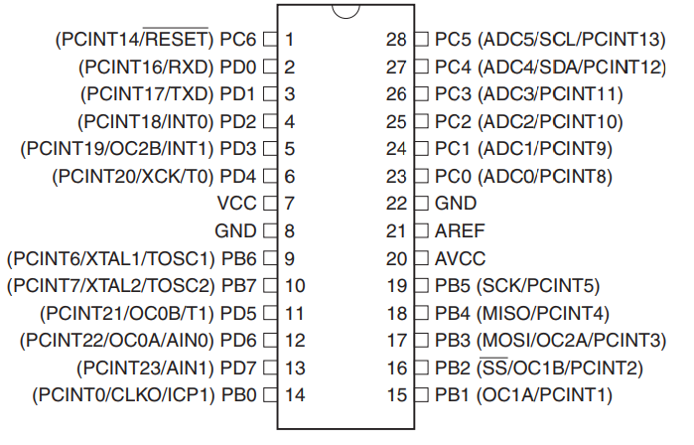

**Figure 1: Pin Uno R3**

***ATMEGA16u2- mu microcontroller***

Is a 8-bit microcontroller used as USB driver in Arduino uno R3 it’s features as follow:

* High Performance, Low Power AVR

**• Advanced RISC Architecture**

* 125 Powerful Instructions – Most Single Clock Cycle Execution
* 32 x 8 General Purpose Working Registers
* Fully Static Operation
* Up to 16 MIPS Throughput at 16 MHz

**• Non-volatile Program and Data Memories**

* 8K/16K/32K Bytes of In-System Self-Programmable Flash
* 512/512/1024 EEPROM
* 512/512/1024 Internal SRAM
* Write/Erase Cycles: 10,000 Flash/ 100,000 EEPROM
* Data retention: 20 years at 85˚C/ 100 years at 25˚Co Optional Boot Code Section with Independent Lock Bits
* In-System Programming by on-chip Boot Program hardware-activated after reset
* Programming Lock for Software Security

**• USB 2.0 Full-speed Device Module with Interrupt on Transfer Completion**

* Complies fully with Universal Serial Bus Specification REV 2.0
* 48 MHz PLL for Full-speed Bus Operation: data transfer rates at 12 Mbit/s
* Fully independent 176 bytes USB DPRAM for endpoint memory allocation
* Endpoint 0 for Control Transfers: from 8 up to 64-bytes
* 4 Programmable Endpoints:
  + IN or Out Directions
  + Bulk, Interrupt and Isochronous Transfers
  + Programmable maximum packet size from 8 to 64 bytes
  + Programmable single or double buffer
* Suspend/Resume Interrupts
* Microcontroller reset on USB Bus Reset without detach
* USB Bus Disconnection on Microcontroller Request

**• Peripheral Features**

* One 8-bit Timer/Counters with Separate Prescaler and Compare Mode (two 8-bit PWM
* channels)
* One 16-bit Timer/Counter with Separate Prescaler, Compare and Capture Mode (three 8- bit PWM channels)
* USART with SPI master only mode and hardware flow control (RTS/CTS)
* Master/Slave SPI Serial Interface
* Programmable Watchdog Timer with Separate On-chip Oscillator
* On-chip Analog Comparator
* Interrupt and Wake-up on Pin Change

**• On Chip Debug Interface (debug WIRE)**

**• Special Microcontroller Features**

* Power-On Reset and Programmable Brown-out Detection
* Internal Calibrated Oscillator
* External and Internal Interrupt Sources
* Five Sleep Modes: Idle, Power-save, Power-down, Standby, and Extended Standby

**• I/O and Packages**

* 22 Programmable I/O Lines
* QFN32 (5x5mm) / TQFP32 packages• Operating Voltages
* 2.7 - 5.5V

**• Operating temperature**

* Industrial (-40°C to +85°C)

**• Maximum Frequency**

* 8 MHz at 2.7V - Industrial range
* 16 MHz at 4.5V - Industrial range
* **Pin configuration**

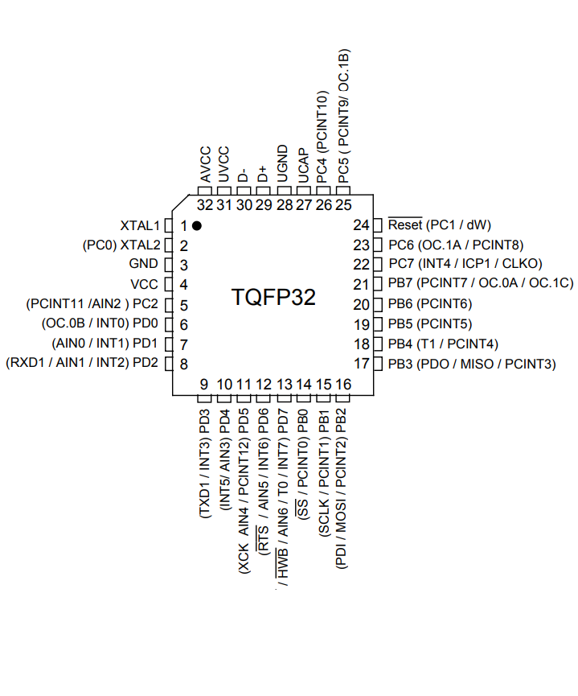

***OTHER ARDUINO UNO R3 PARTS***

**Input and Output**

Each of the 14 digital pins on the Uno can be used as an input or output, using pinMode (), digitalWrite(), and digitalRead() functions. They operate at 5 volts. Each pin can provide or receive a maximum of 40 mA and has an internal pull-up resistor (disconnected by default) of 20-50 k Ohms. In addition, some pins have specialized functions:

* Serial: 0 (RX) and 1 (TX). Used to receive (RX) and transmit (TX) TTL serial data. These pins are connected to the corresponding pins of the ATmega8U2 USB-to-TTL Serial chip.
* External Interrupts: 2 and 3. These pins can be configured to trigger an interrupt on a low value, a rising or falling edge, or a change in value.
* PWM: 3, 5, 6, 9, 10, and 11. Provide 8-bit PWM output with the analogWrite() function.
* SPI: 10 (SS), 11 (MOSI), 12 (MISO), 13 (SCK). These pins support SPI communication using the SPI library.
* LED: 13. There is a built-in LED connected to digital pin 13. When the pin is HIGH value, the LED is on, when the pin is LOW, it's off.

The Uno has 6 analog inputs, labeled A0 through A5, each of which provide 10 bits of resolution (i.e.1024 different values). By default they measure from ground to 5 volts, though is it possible to change the upper end of their range using the AREF pin and the analogReference() function.

Additionally, some pins have specialized functionality:

* TWI: A4 or SDA pin and A5 or SCL pin. Support TWI communication using the Wire library.

There are a couple of other pins on the board:

* AREF: Reference voltage for the analog inputs. Used with analogReference().
* Reset: Bring this line LOW to reset the microcontroller. Typically used to add a reset button to shields which block the one on the board.

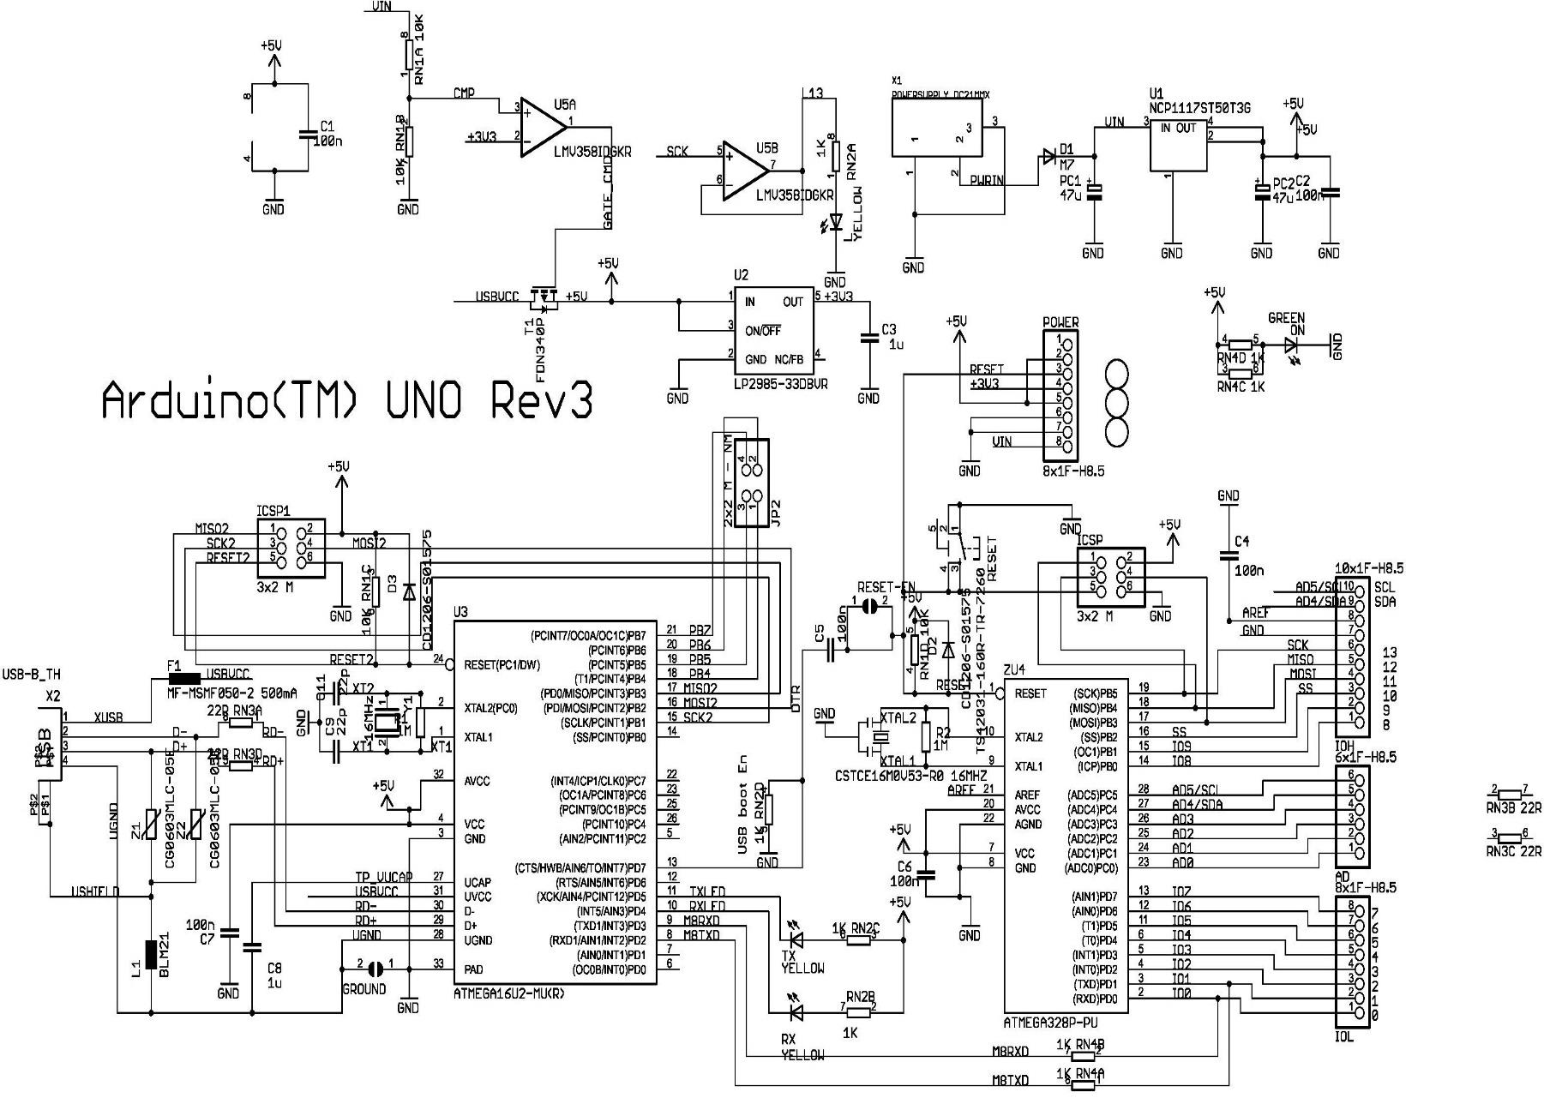

Figure : Overview of Uno R3

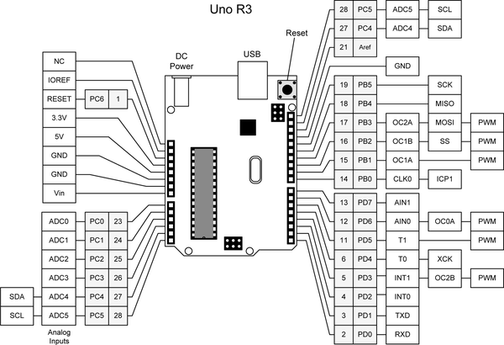

Figure : ARDUINO UNO R3 SCHEMATIC DIAGRAM

## **2.2 Introduction of light sensor BH1750**

BH1750 Is a Digital Light sensor, which is an digital Ambient Light Sensor IC for I2C bus interface. This IC is the most suitable to obtain the ambient light data for adjusting LCD and Keypad backlight power of Mobile phone. It is possible to detect wide range at High resolution (1 - 65535 lx).

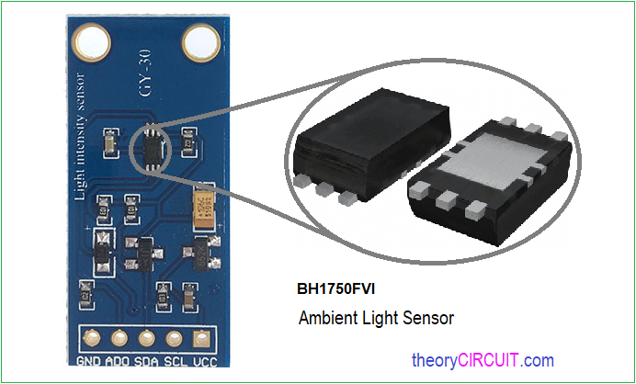

**Figure 4: Light Sensor BH1750**

***~ This sensor has some advantages such like:***

1. Illuminance to Digital Converter
2. Wide range and High resolution. (1 - 65535 lx)
3. Low Current by power down function
4. 50Hz / 60Hz Light noise reject-function
5. I2C bus Interface (f / s Mode Support)
6. No need any external parts
7. It is possible to select 2 type of I2C slave-address.
8. It is possible to detect min. 0.11 lx, max. 100000 lx by using this function**.**

***~ It's easy to use and connect, so Let's started***

**# We will need:**

* Arduino Board" Uno, Nano, mini… "
* BH1750 Breakout.
* Solderless Jumper
* CD4050 Hex Buffer IC, Or 510 Ohm resistor *3
* BreadBoard

**# Lumen:** The unit for the quantity of light flowing from a source in any one second (the luminous power, or luminous flux) is called the lumen.

In our sensor we will take a reading from it in Lux which is equal to one lumen per square metre:

Lux = 1 Lm/m2

## **2.3 Introduction of LCD 1602**

The LCD 1602 (Liquid Crystal Display) is used in many microcontroller applications. It has many benefit over other display formats such as: the ability to display diverse characters (graphic characters, letters, numbers,); put into application circuit according to many different communication protocols easily, consume very little system resources, low cost, ...

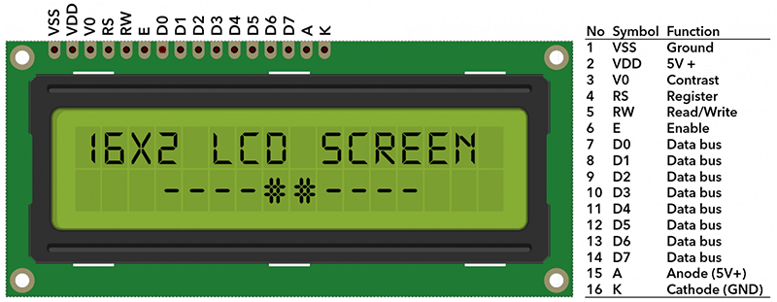

Figure : LCD

*Specifications of LCD 1602:*

* + *MAX voltage: 7V*
  + *MIN voltage: - 0.3V*
  + *Low output voltage: <0.4V*
  + *High output voltage: > 2.4*
  + *Stable operation: 2.7-5.5V*
  + *Power supply current: 350uA - 600uA*
  + *Operating temperature: - 30 - 75 degrees Celsius*

Table : PIN LCD 1602

|  |  |  |  |
| --- | --- | --- | --- |
| **PIN** | **SYMBOL** | **DESCRIBE** | **VALUE** |
| 1 | VSS | GND | 0V |
| 2 | VCC |  | 5V |
| 3 | V0 | Contrast |  |
| 4 | RS | Value selection force | RS = 0 (high level)  RS =1 (low level) |
| 5 | R/W | Select data read/write register | R/W=0 write register  R/W=1 read register |
| 6 | E | Enable |  |
| 7 | DB0 | Pin | 8 bit: DB0D87 |
| 8 | DB1 | Data pin |  |
| 9 | DB2 |  |  |
| 10 | DB3 |  |  |
| 11 | DB4 |  |  |
| 12 | DB5 |  |  |
| 13 | DB6 |  |  |
| 14 | DB7 |  |  |
| 15 | A | LED background anode | 0V đến 5V |
| 16 | K | LED background cathode | 0V |

## **2.4 Introduction of AC Dimmer Module**

The AC dimmer module with high power, easy to connect to microcontroller to adjust lamp brightness, AC motor speed, thermostat temperature control… . Dimmer is often used for home systems smart. For example, when you need to change the light brightness smoothly. Lights slowly turn ON or OFF, creating a comfortable atmosphere. Dimmer works best with filament lights.

The power part of the dimmer is isolated from the control part, to eliminate the possibility of high current interruption to the microcontroller.

**Structure of the module**

* MCT2E optocoupler -1
* MOC3021 optocoupler -1
* BT136 TRIAC-1
* ABS 210 Bridge Rectifier-1
* Resistor

**Function of the components**

* *ABS 210 Bridge Rectifier*

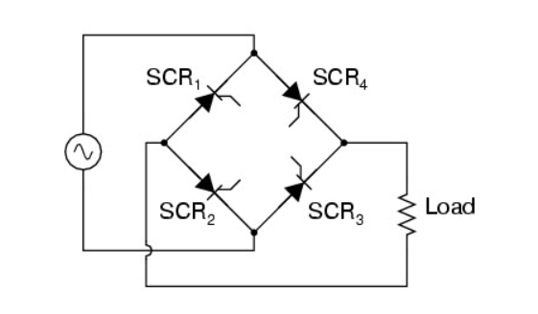

**Figure 6: Structure of the bridge circuit**

* Using a rectifier circuit in the power supply converts AC power to DC. The most prominent of which is the bridge rectifier circuit, which is widely used in large equipment. Where they are capable of converting high a.c. voltage to low-d.c. electricity.
* Using a transformer is a simple way to change the output to the desired DC voltage. Then the rectifier circuit can supply power to motors, led lights or devices operating with DC power.

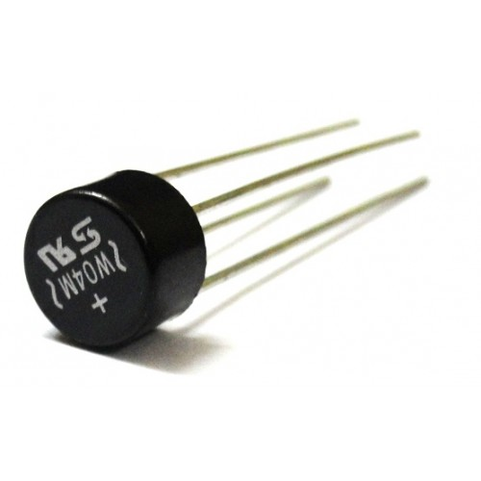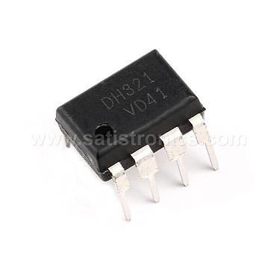

* *MOC3021 optocoupler*

The MOC3021 is an optocoupler or optoisolator that controls the zero point detection TRIAC. As we know the term optocoupler or optoisolator means we use light to connect indirectly to the electrical circuit. The special feature of the MOC3021 is that it is not capable of detecting and being driven by a Triac.

Table : PIN MOC3021

|  |  |  |
| --- | --- | --- |
| **STT chân** | **Tên chân** | **Mô tả** |
| 1 | Anode (A) | Positive pin of IR LED, connected to logic input |
| 2 | Cathode (C) | Negative foot of infrared LED |
| 3 | NC | Not Connected - Can't Use |
| 4 | Triac MT1 | One pin of Triac is present inside IC |
| 5 | NC | Not Connected - Can't Use |
| 6 | Triac MT2 | One pin of Triac is present inside IC |
|

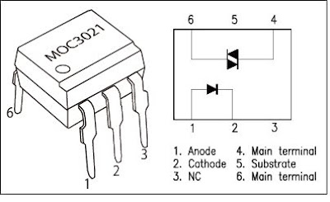

**Figure 7: Pin MOC3021**

**Features and specifications of the MOC3021**

* Optoisolator with zero detection triac control
* Input LED diode forward voltage: 1.15V
* LED forward latch current: 15mA
* TRIAC output pin voltage: 400V (max)
* TRIAC peak output current: 1A
* Available in 6-pin PDIP with and without the CODE suffix

**How to use MOC3021**

MOC3021 is commonly used to control AC equipment, such as bulb brightness, motor speed, etc. Either way, the optocoupler will not be allowed to drive the load directly due to the current rating. its limitations. It is usually connected to another power switch such as a TRIAC. This TRIAC will be able to provide enough current for transmission and will be controlled using an optocoupler. Below is a simple circuit diagram where an AC light bulb is controlled by a microcontroller.

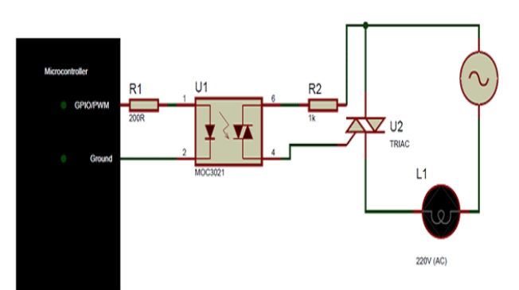

The MOC3021 can be used to switch the load by turning the LED on or off, or we can also use the PWM signal to switch the LED and TRIAC. When we convert the **TRIAC** with a PWM signal then the output voltage on the load can be controlled thereby controlling the speed or brightness of the load.

When transferring AC loads, it is important to understand the switching speed of the optocoupler. This switching speed depends on the amplitude of the voltage controlled by the TRIAC and the operating ambient temperature.

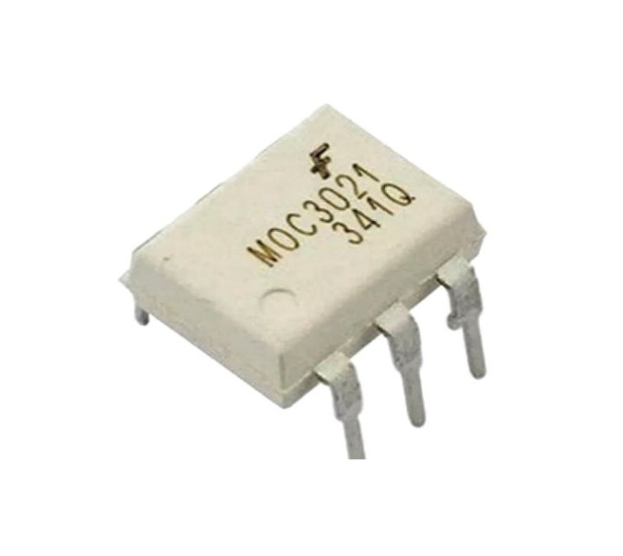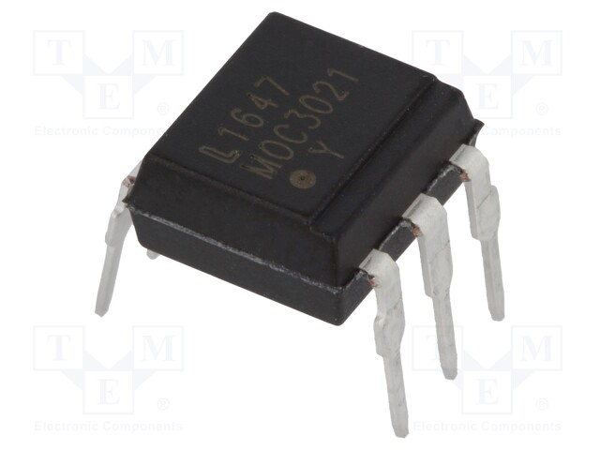

* *MCT2E optocoupler*

What is optcoupler?

An opto-isolator is a specialized opto-electronic device for transmitting control signals between two circuits with high voltage differences through light without needing to communicate with each other by electrical signals.

=> We can also electrically isolate the input signal source and output load with just light using a very common and useful electronic component called an opto-coupler. or opto-isolator



Figure : Pin MCT2E

**Structure of Optocoupler**

The opto-isolator consists of 2 main components:

* Luminous part: The light-emitting device on the input side takes the incoming signal and converts it into a light signal. A typical light-emitting device is a light-emitting diode (LED - Light Emitting Diode).
* Light Receiver: The light detector/detector in the optocoupler will detect/receive light from the component in the emitter and convert it back into an electrical signal. The light receiving device can be a photodiode, phototransistor, photoresistor, optical SCR or optical TRIAC.

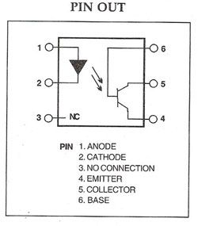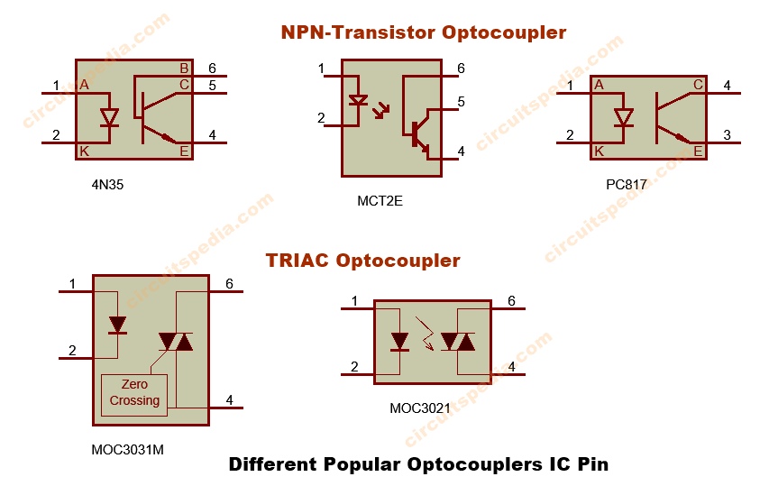

**Operation principle and application of optocoupler**

Common applications of optocouplers include microprocessor input/output switching, DC and AC power control, PC communication, signal isolation, and more. The electrical signal transmitted can be analog (linear) or digital (pulse).

In this application an opto-isolator is used to detect the open/closed state of the switch or some kind of digital signal at the input. This is useful if the switch or signal is detected in an electrically noisy environment. The output can be used to control external circuits, lighting, or as an input to a PC or microprocessor**.**

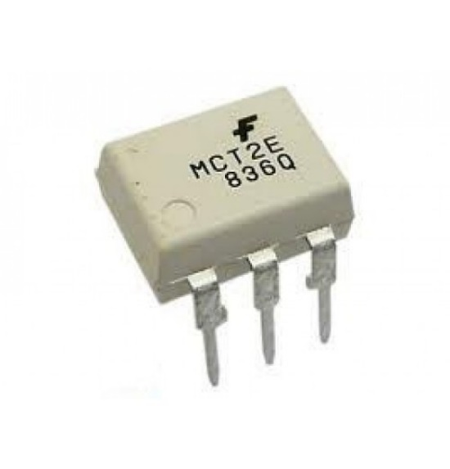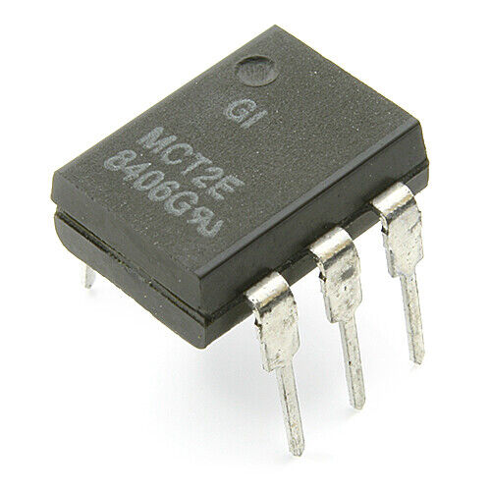

* *BTA16 TRIAC*

TRIAC (short for TRIode for Alternating Current) is a device that can conduct current in both directions. Therefore, the definition of forward and reverse current does not make sense, the same goes for the concept of reverse voltage. Triac excitation is done by the current pulse applied to the control gate G.

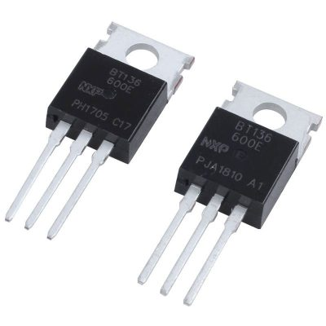

**Triac structure**

* The triac consists of 3 poles and 5 semiconductor layers creating a P-N-P-N structure as in a thyristor in both directions between terminals T1 and T2. Therefore, it can conduct current in both directions between T1 and T2.

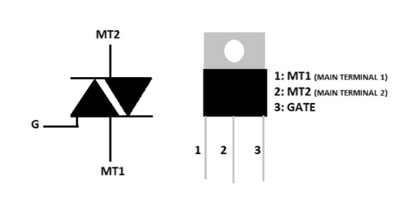

Figure : Triac Pin

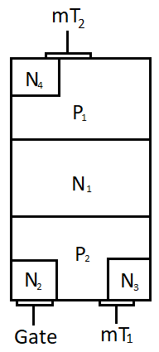

* The triac can be thought of as equivalent to two thyristors connected in parallel in opposite directions. To control the triac, simply feed a pulse to the triac's G pin.
* The Triac has four potential combinations that can be opened for flow:

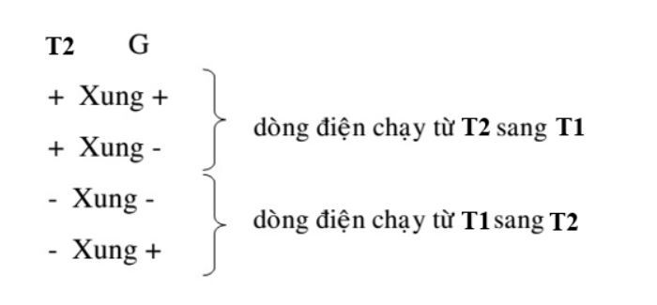

**Working Principle**

The TRIAC can control current conduction with both positive (current entering the control terminal) and negative (current leaving the control terminal) pulses. However, the negative control current pulse has less sensitivity, that is, to open the TRIAC will require a larger negative control current than the positive control current.

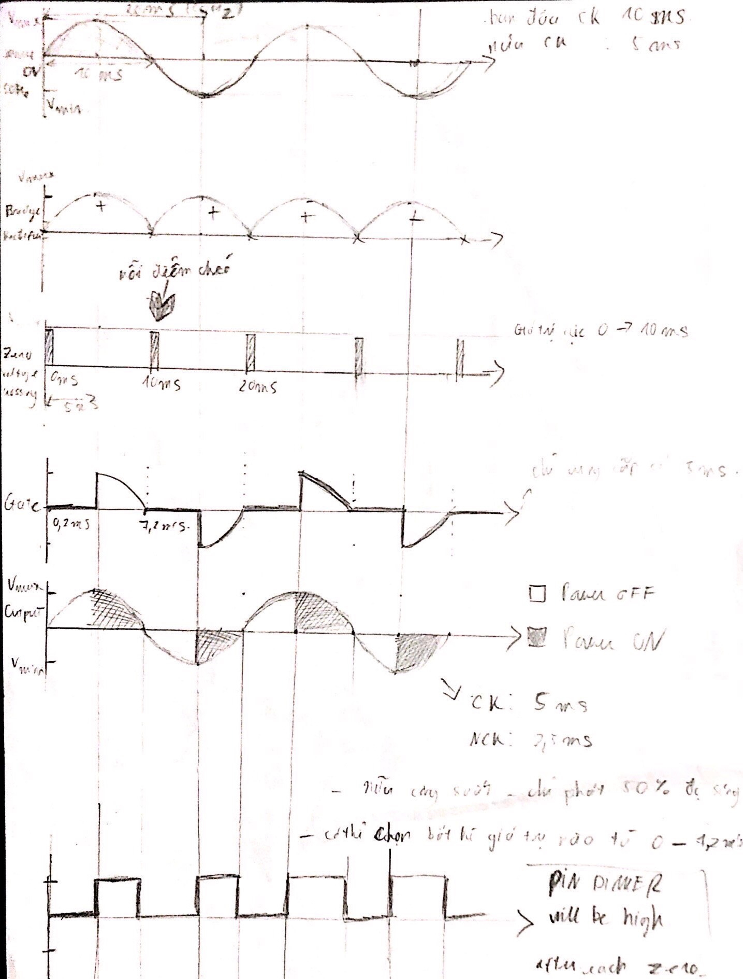

Figure : Graph showing the principle of circuit transformation through components

## **2.5 Introduction to I2C communication standards**

The I2C is a serial bus protocol consisting of two signal lines such as SCL and SDL lines which are used to communicate with the devices. The SCL stands for a ‘serial clock line’ and this signal is always driven by the ‘master device’. The **SDL stands** for the ‘serial data line’, and this signal is driven by either the master or the I2C peripherals. Both these SCL and SDL lines are in open-drain state when there is no transfer between I2C peripherals.

* *How does I2C communication work?*
* **I2C uses 2 signal lines:**
* SCL - Serial Clock Line: Generate clocks transmitted by Master
* SDA - Serial Data Line: Line receiving data.

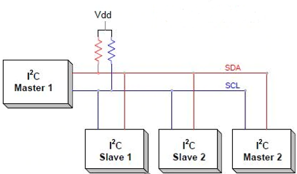

Figure : I2C

* I2C communication includes the process of transmitting and receiving data between a master device and a slave device, also known as Master - Slave.
* The Master device is a microcontroller, it is responsible for controlling the SCL signal line and sending and receiving data or commands via the SDA line to other devices.
* Devices that receive command and signal data from the Master device are called Slave devices. Slave devices are usually ICs, or even microcontrollers
* *Data transfer process:*

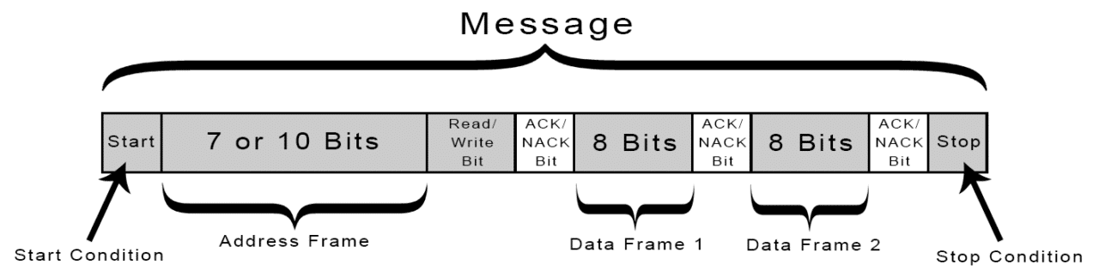

**Step 1:** Master sends start condition (*The master sends a start condition to every connected slave by switching the SDA line from high voltage to low voltage before switching the SCL line from high to low*).

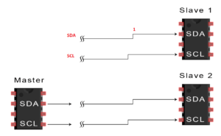

**Step 2:** Master sends address out to network (7 or 10 bits)

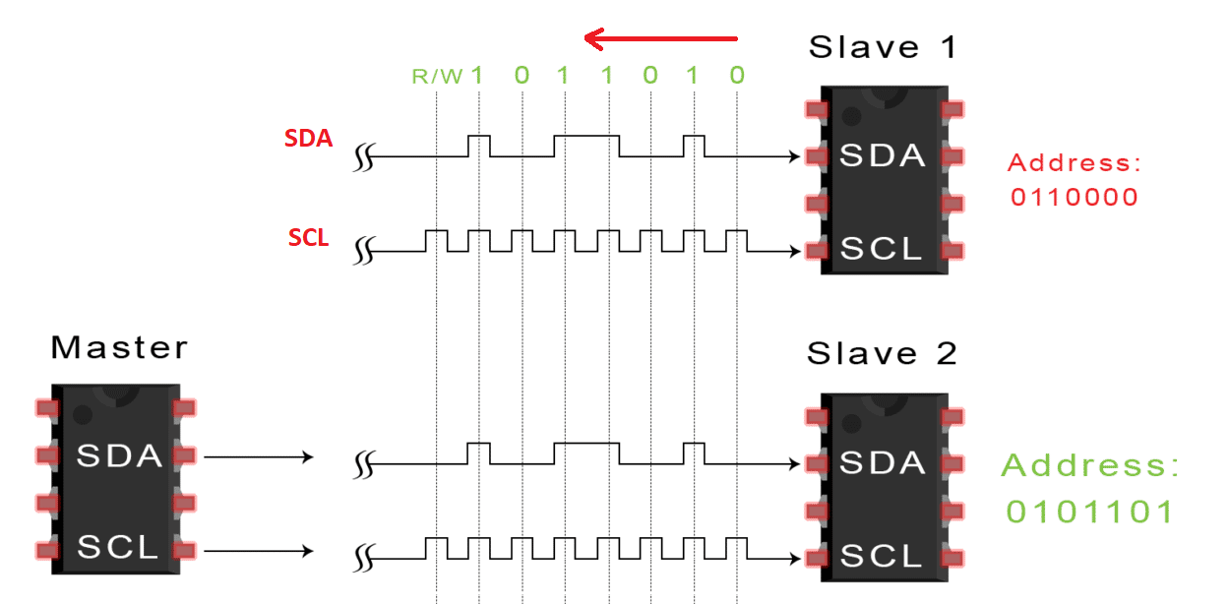

**Step 3:** Slave compares sent address *(The slave compares the address sent from the master with its own address. If the address matches, the sub will return an ACK bit by pulling the SDA line one bit low. If the address from the master does not match the address of the slave itself, the slave will remain high)*

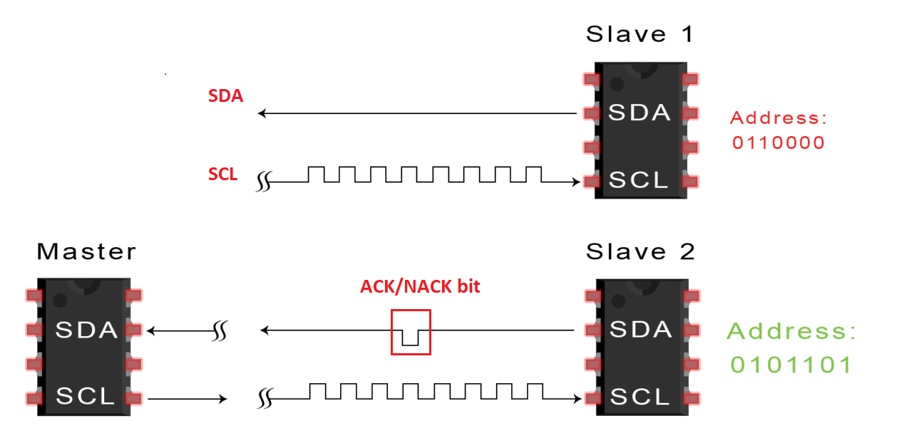

**Step 4:** Master sends (or receives) data frame

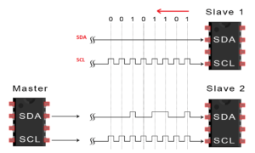

**Step 5:** Master sends stop command (Stop condition) [*to stop data transmission, the master sends a Stop condition to the slave. At this point the master will convert the SCL current to high before switching the SDA current to high.*

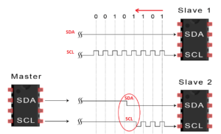

* **Some IC devices use I2C**

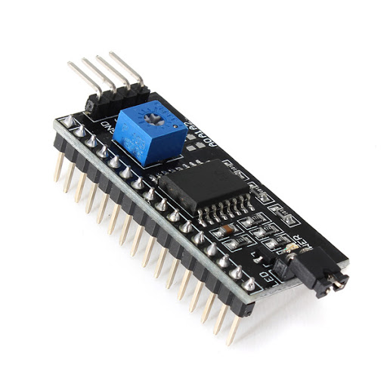

**Module I2C for LCD**

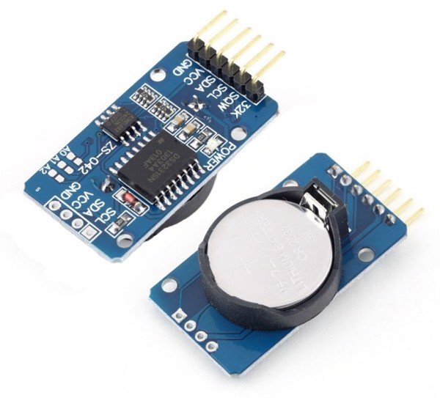

**Types of real-time modules DS3231**

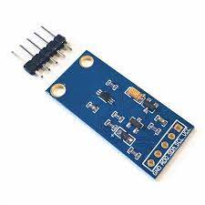

**Light sensor bh1750**

* *Advantages and disadvantages of standard I2C communication*

Table : Benefit and drawback of I2C

|  |  |
| --- | --- |
| **Advantage** | **Disadvantage** |
| Use only two wires | I2C communication data transfer rate is slower than SPI communication |
| Supports multiple masters and multiple slaves | The size of the data frame is limited to 8 bits |
| The ACK/NACK bit confirms that each data frame or address has been sent (or received) successfully | Requires more complex hardware to implement than SPI communication |
| Hardware is less complicated with UART. contact  Well-known and widely used protocol |  |

## **2.5 Introduction to Signal**

* *What is analog signal?*

An analog signal or an analog signal is a signal that is transmitted continuously (without interruption) that changes in time. That is, after one cycle the signal will be repeated and differ only in magnitude. Theoretically, this type of signal can stay in shape indefinitely, but during actual transmission it will be affected by noise, resulting in signal distortion. Some Analog signals that we encounter every day such as sound, light, angular speed, frequency,..

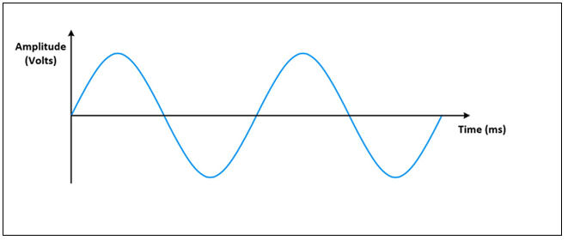

Figure : Analog signal

* *What is Digital signal?*

A digital signal is a digital signal (discrete signal), used to represent data as a series of discrete values ​​at any given time. Digital signals can only accept one of two fixed values, high and low. Thus, in computer science, this level is represented in binary as 1 (high) and 0 (low), while in industry it is On/Off. This type of signal represents a real number in the range of constant values

Represented on voltages from 3.5V to 5V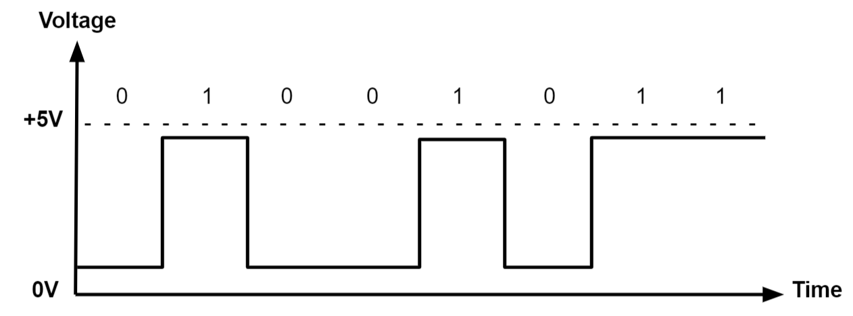

Figure : Digital Signal

Table : Compare analog and digital signal

|  |  |  |
| --- | --- | --- |
|  | **Analog** | **Digital** |
| Status signal | A continuous signal representing physical measurements. It uses a series of contiguous values ​​to help you present information | Signals spaced by time. It uses discrete 0s and 1s to represent information |
| Bandwidth usage | LOW | HIGH |
| Transmission quality | NORMAL | HIGH |
| Signal processor speed |  | there are many delays and restrictions |

## **2.6 Introduction to PMW Pulse**

PWM (Pulse Width Modulation) is to modulate (change) the width of the pulse (the time difference between the "ON" and "OFF" pulses) without changing the frequency of the electrical signal.

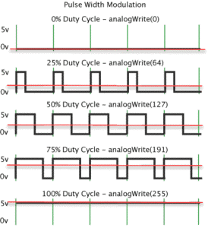

* *Pulse modulation calculation formula*

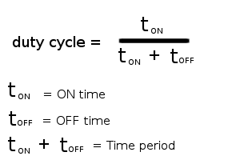

* *How to generate PWM modulation pulse*

For example at a frequency of 50Hz design a PWM modulated signal with a duty cycle of 60%.

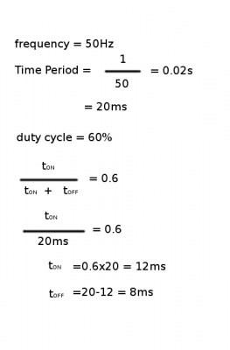

The PWM signal now has the following form:

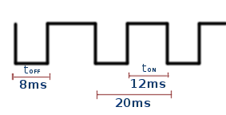

So to generate such a pulse sequence, the programmer only needs to write a program for the microcontroller. Every 8ms the output pulls up 1, then at 1 exactly 12ms pulls the output down to 0. Just like that, with a cycle of 20ms repeating that pulse, we can create the desired pulse sequence with frequency 50Hz and equal frequency. modulation depth is 60%

# **CHAPTER 3. ALGORITHMS AND CONTROLS**

## **3.1 System Operation**

When the ON/OFF button is pressed, the light will turn on at 0 and in manual mode. And then press the auto mode selection button, the light will automatically adjust the light according to the surrounding environment

## **3.2 Algorithm flowchart on microcontroller**

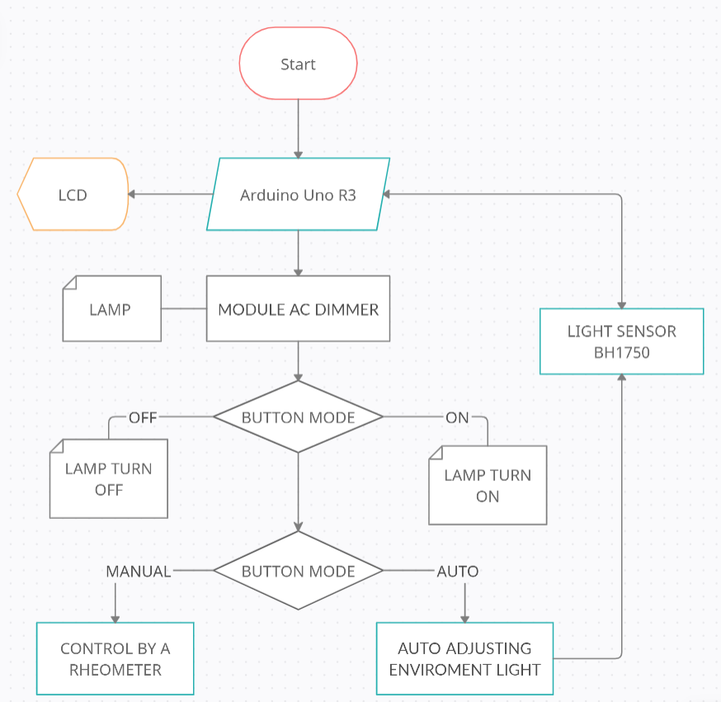

Figure : Algorithm

# **CHAPTER 4. DESIGN AND CONSTRUCTION**

## **4.1 Block diagram of the system**

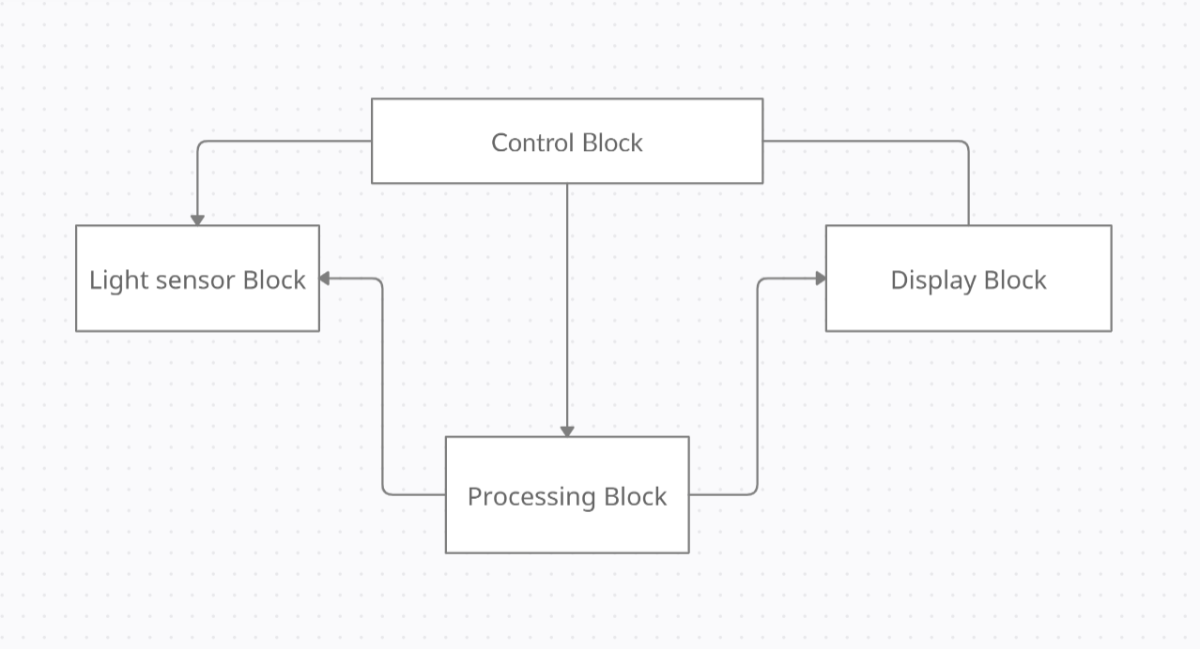

Figure : Block

### **4.1.1 Control block**

* Function: Allows current control
* Used: Rheostat, Module AC dimmer
* Specifications: The same 2.4
* 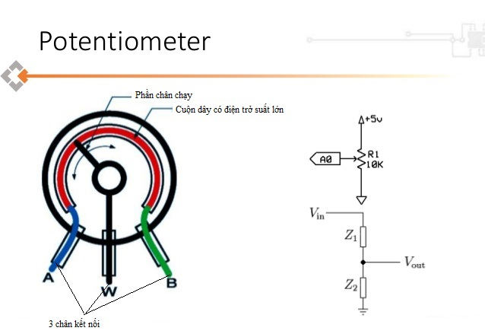**Rheostat**
* Pin A: Connect to Vcc 5V
* Pin W: Connect to pin A0 (analog pin)
* Pin B: Connect to GND

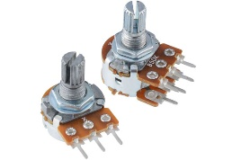

Figure : Rheostat

### **4.1.2 Processing Block**

* Function: Processing signals sent to sensors and control block
* Used: Uno R3
* Specifications: The same 2.1
* *Pins connected to Uno R3*

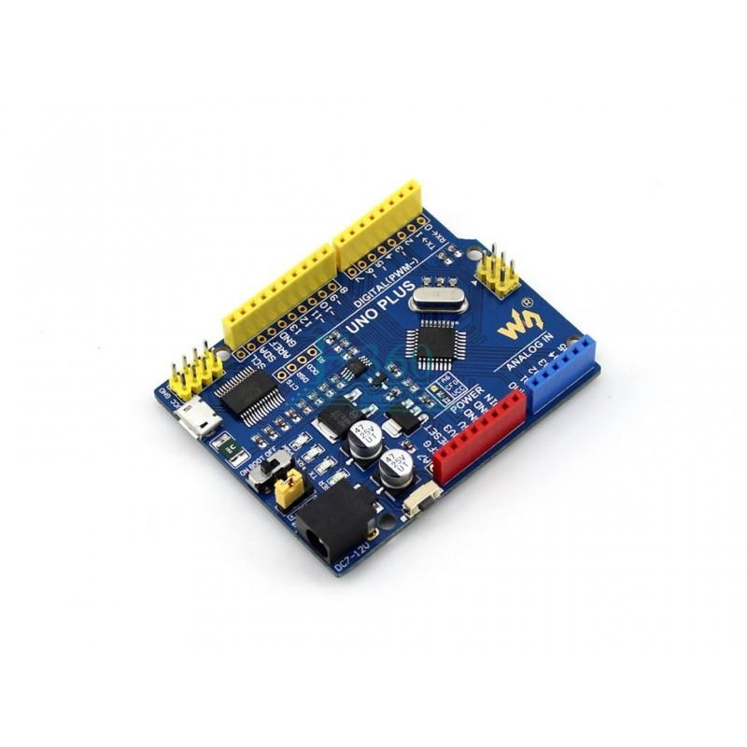

**Light sensor BH1750:**

* Vcc connect to 5V source
* GND connect to GND of Uno R3
* The pins to transmit SDA and SCL data are A4 A5 pins of Uno R3

LCD 16x2 i2C:

* Vcc connect to 5V source
* GND connect to GND of Uno R3
* The pins to transmit SDA and SCL data are A4 A5 pins of Uno R3

**Rheostat:**

* Vcc connect to 5V source
* GND connect to GND of Uno R3
* Analog pin A0 of Uno R3

**Module AC dimmer:**

* Vcc connect to 5V source
* GND connect to GND of Uno R3
* Pin Zerocrossing
* Dimmer

### **4.1.3 Light Sensor Block**

* *Light BH1750 sensor*

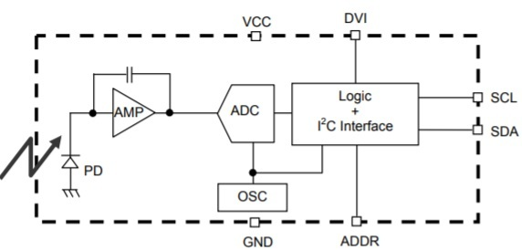

Figure : Block diagram of BH1750

**Pin Diagram:**

* Pin 1 (Vcc) is the power supply pin. The supply voltage ranges from 2.4V to 3.6V.
* Pin 2 (GND) is the ground pin. This pin is connected to the ground of the circuit.
* Pin 3 (SCL) is the Serial Clock Series. This pin is used to provide clock pulses for the I2C communication between the sensor and the microprocessor.
* Pin 4 (SDA) is the Serial Data Address. This pin is used by the I2C interface to transfer data from the sensor to the microcontroller.
* Pin 5 (ADDR) is the Device Address Pin. This pin is used when multiple modules are connected, to select the address.

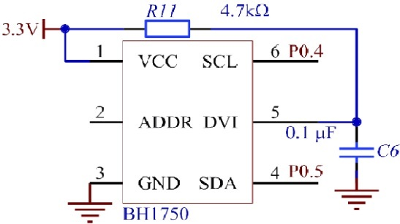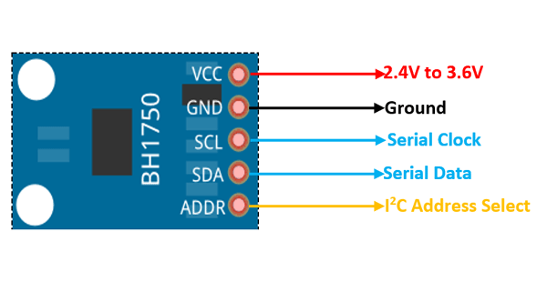

**# How to calculate lux?**

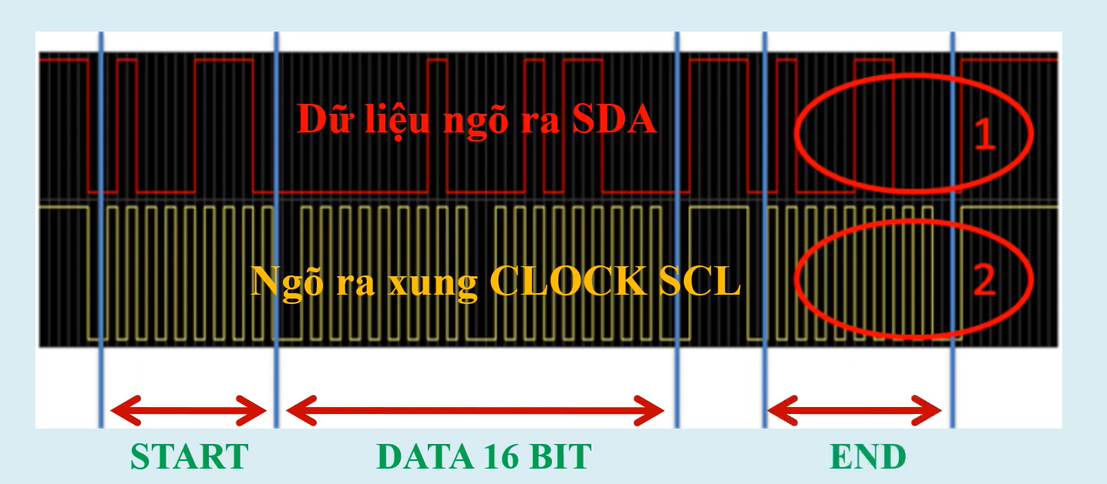

**Example:**

Value read at the falling edge of the first 8 pulses of the SCL (ignoring 8 Start and 8 End bits)

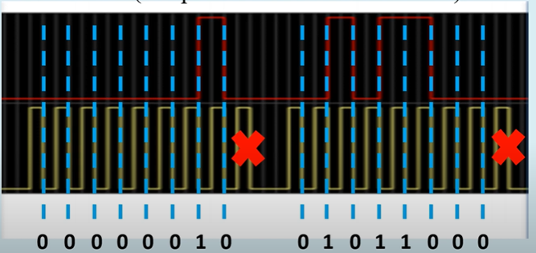

Figure : Example of caculate light sensor

**Solution**

Look at the picture we have digital signal at SDA output: 0000 0010 01011000

=> The illuminance of light is defined as $\frac{(2^{9}+2^{6}+2^{4}+2^{3})}{1×2}=300 lux$

**# Standard of illuminance**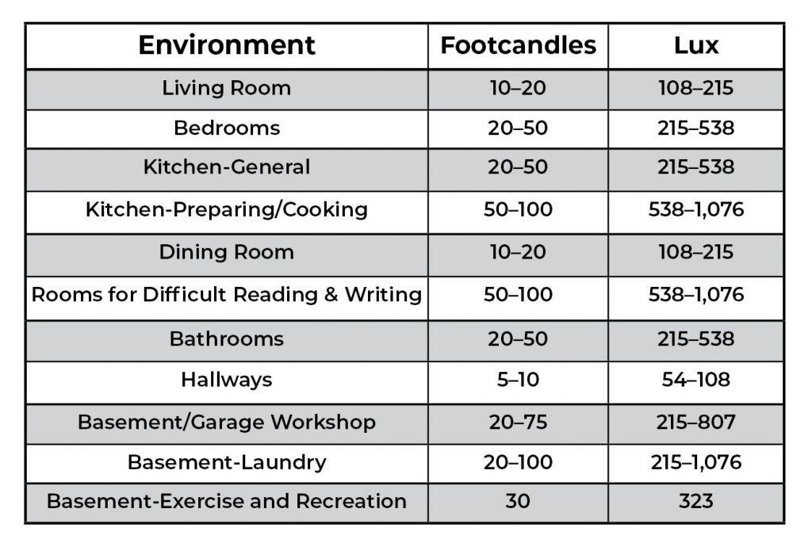

Figure : Standard of illuminace

### **4.1.4 Display Block**

Function: Display light status and ambient brightness

Used: LCD 16x2 I2C

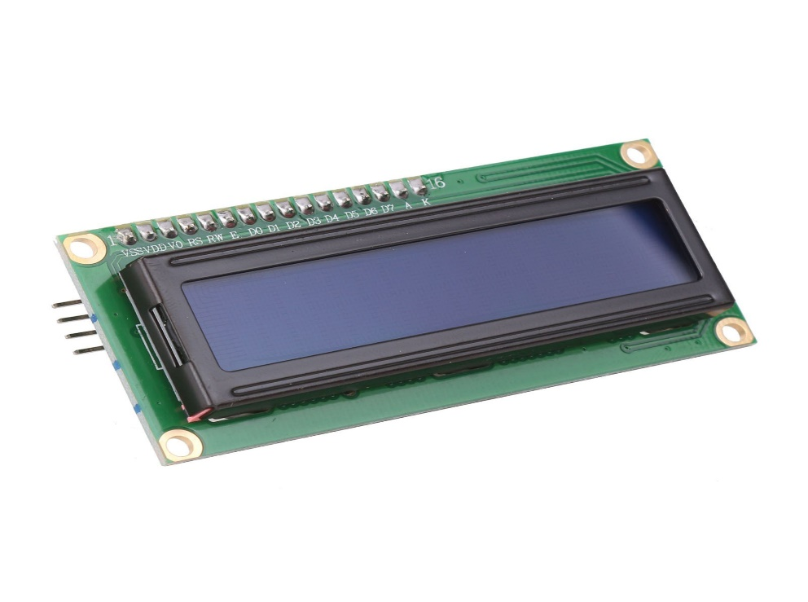

## **4.2 Model Design**

### **4.2.1 Circuit Design PCB**

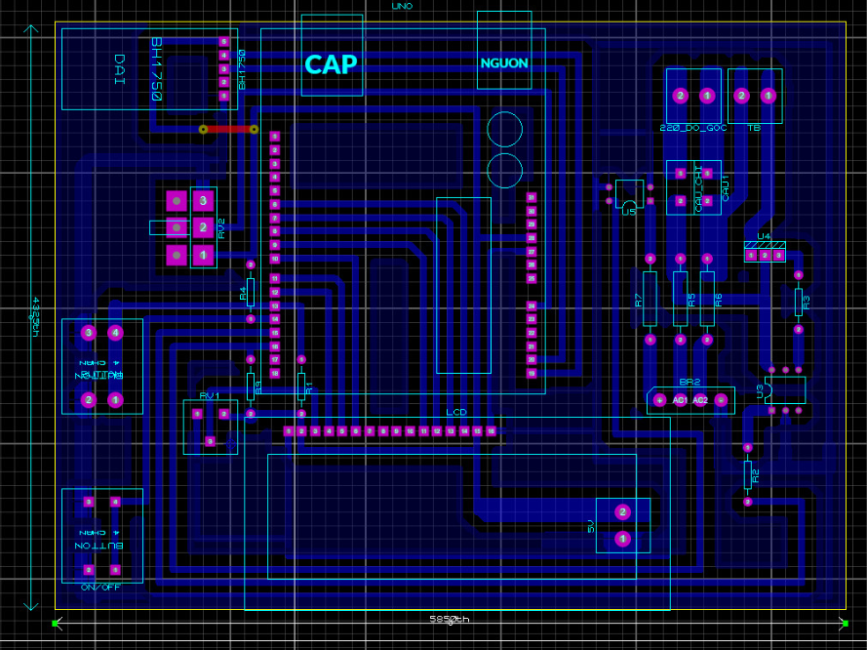

**4.2.2 Proteus Simulation Circuits**

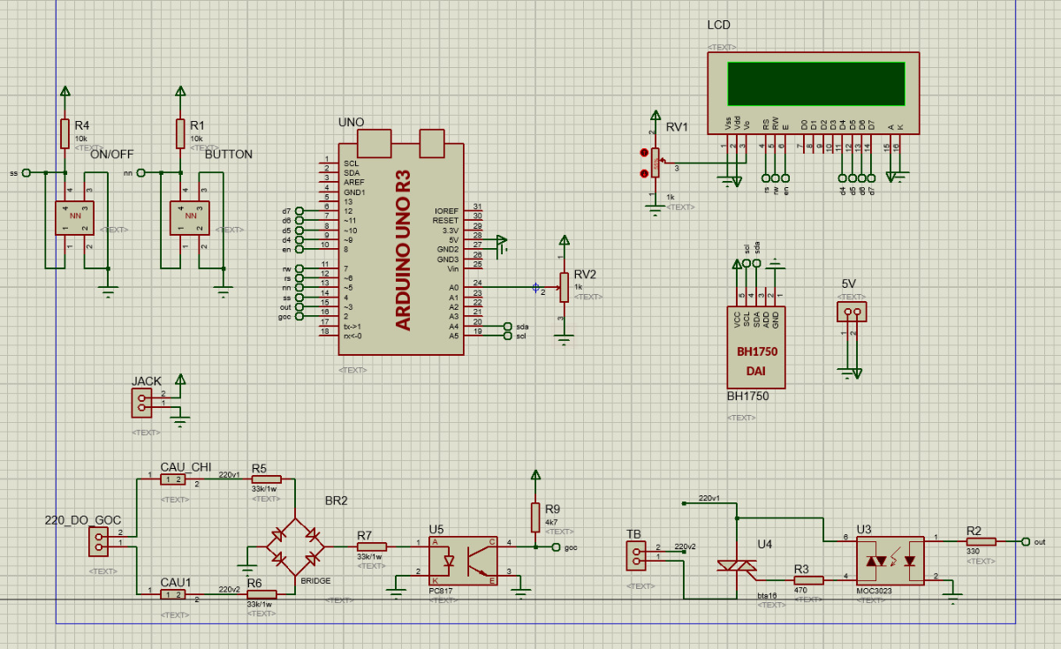

**4.2.3 Hardware**

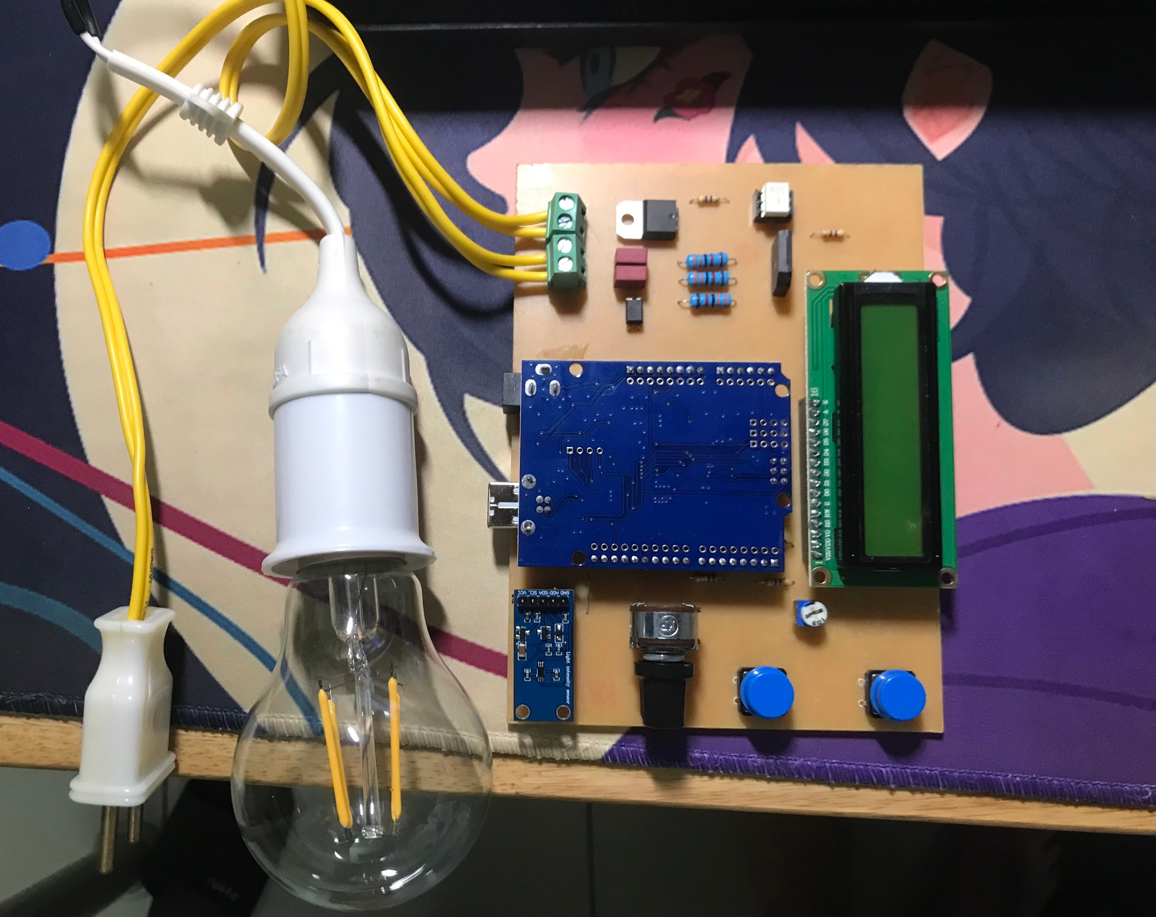

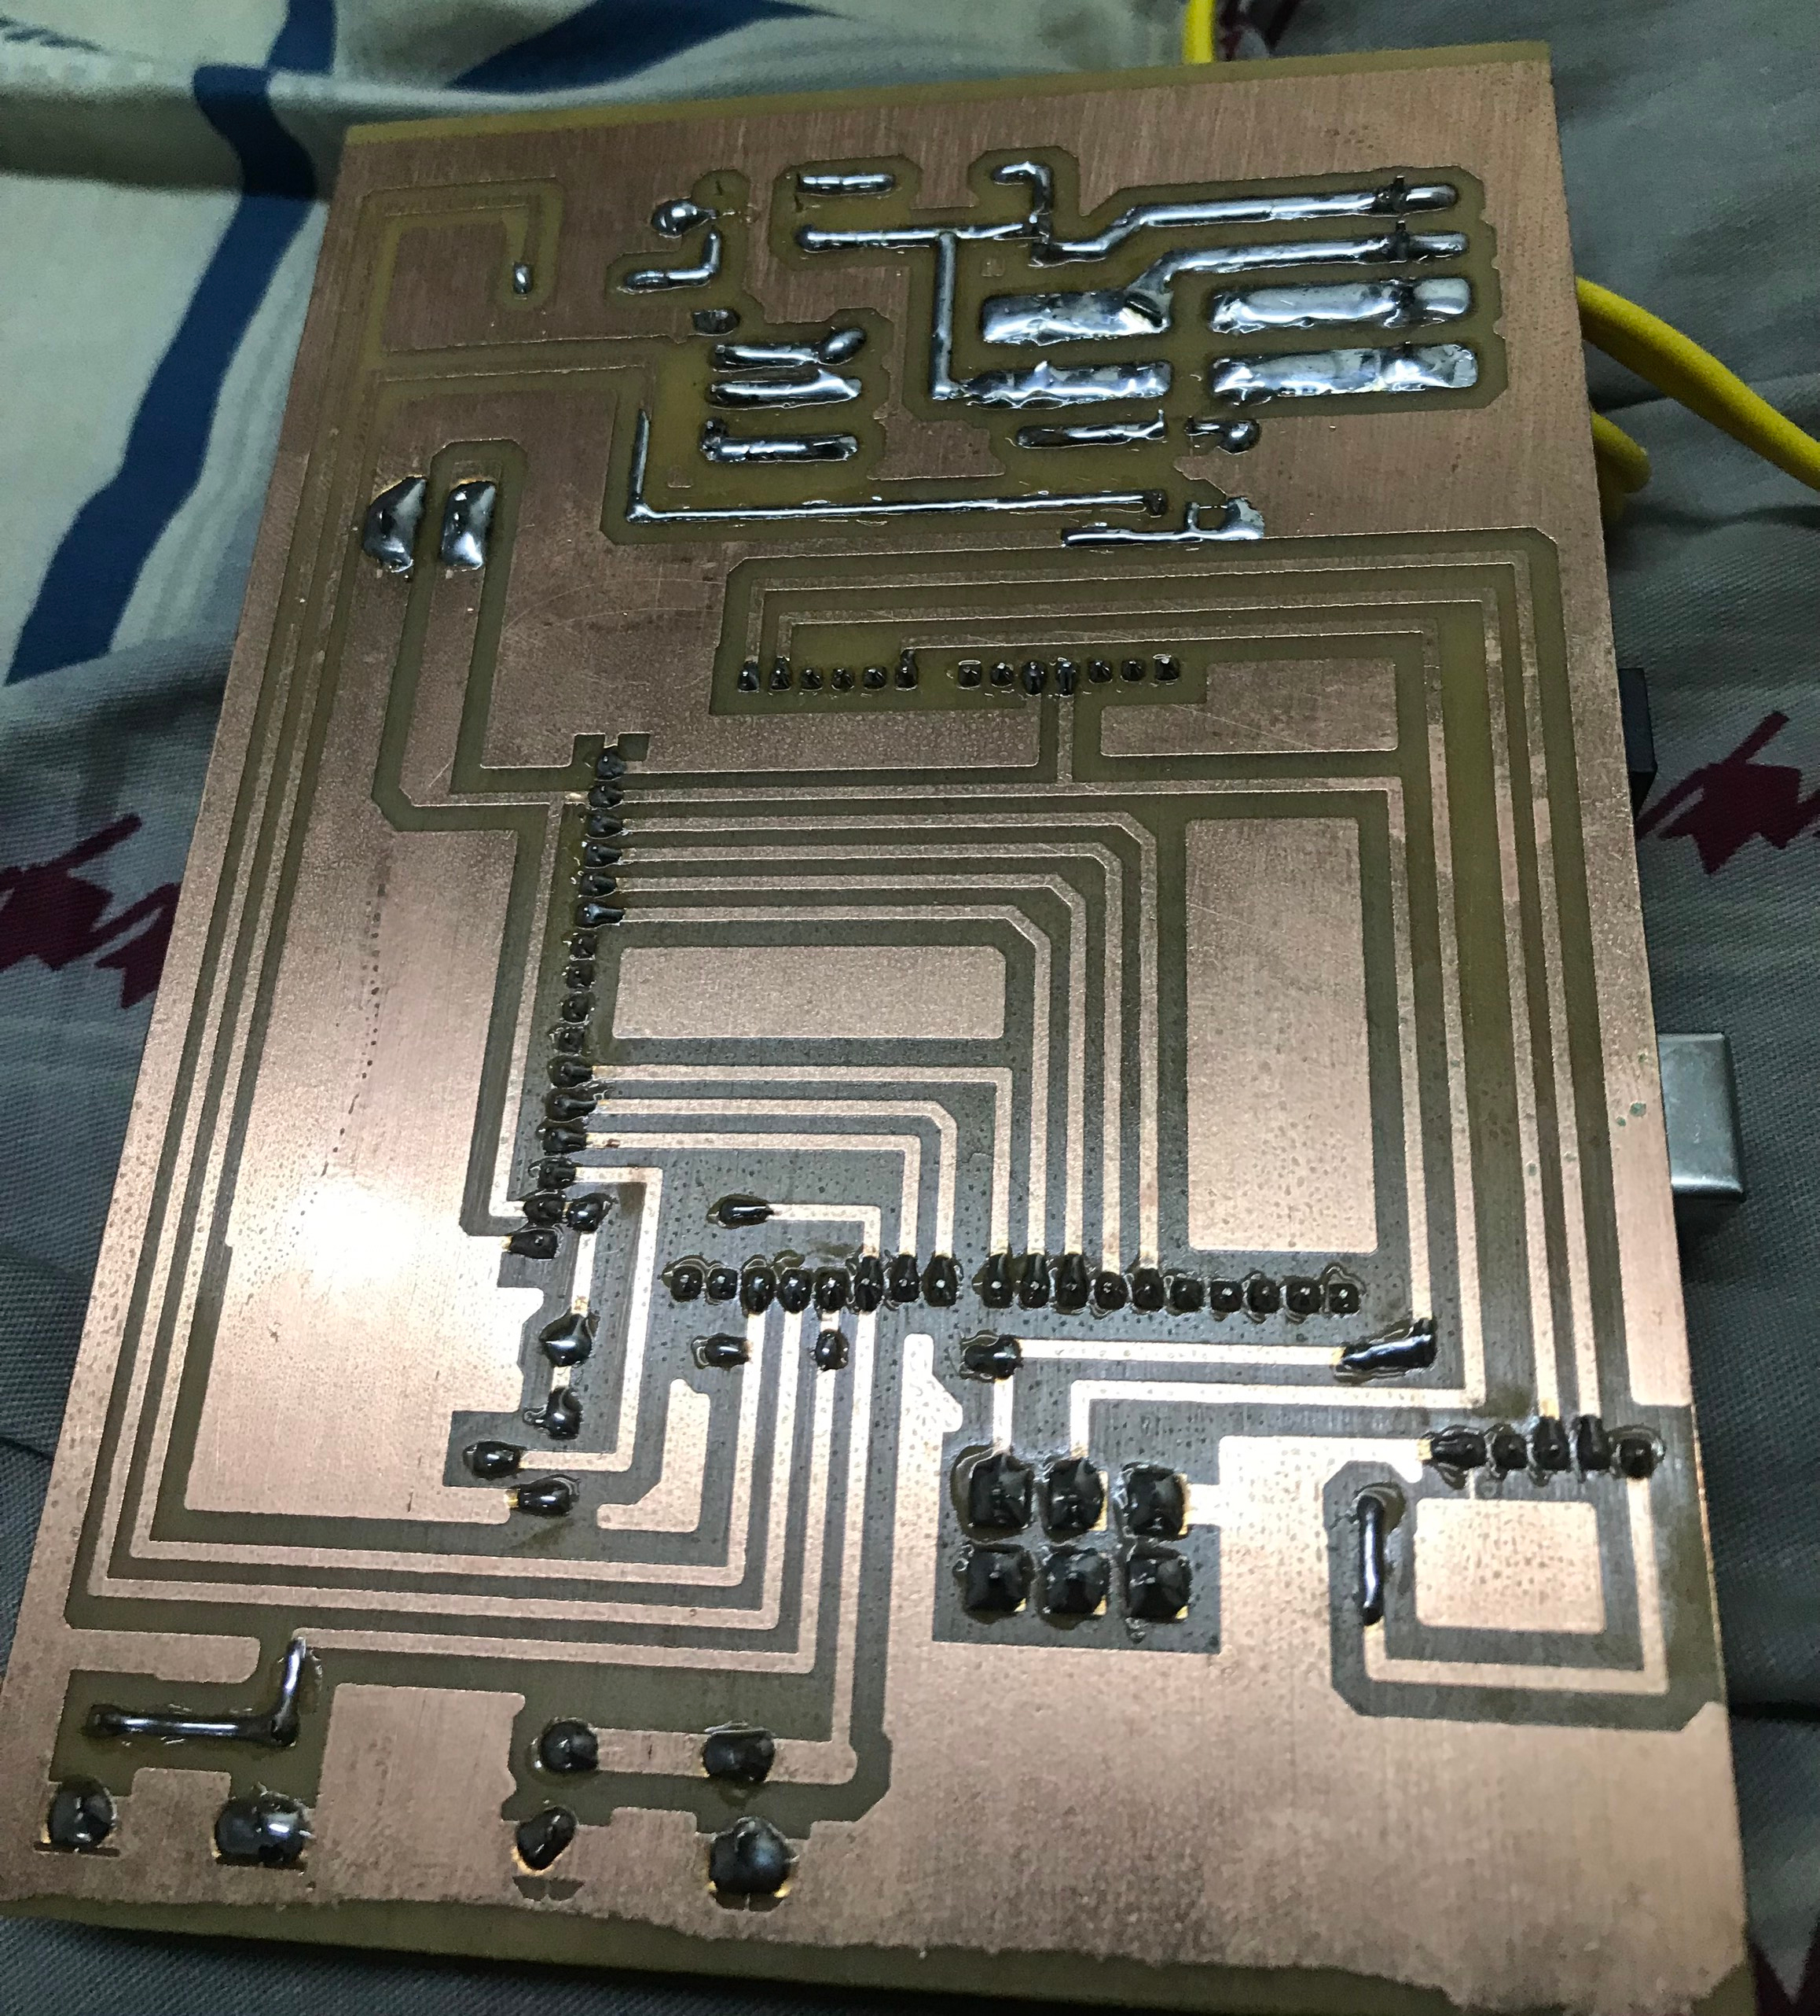

## **4.3 Experiment**

### **4.3.1 Implementation process**

* Step 1: Press the ON/OFF button to start the system
* Step 2: Press the mode button to select auto and press again to return to manual
* Step 3: Press the ON/OFF button to stop the system

### **4.3.2 Results**

* Pressing the ON/OFF button to start the system, the LCD will show the mode status and the light sensor will be activated.
* Next, we press the Mode button to select auto or manual and lcd shows manual mode to auto or vice versa
* After starting the auto mode, the light will automatically adjust to the surrounding environment
* When starting the manual mode, the light will be controlled by the rheostat
* Then press ON/OFF button to stop the system stop working.

### **4.3.3 Experiment overview**

The circuit has met the requirements, but the PID has not been applied, the LCD displays all the information required, the auto mode switch is not smooth.

# **CHAPTER 5. CONCLUSION**

## **5.1 Advantage**

- Simple circuit, easy to use, can adjust two desired modes

## **5.2 Disadvantage**

**-** The circuit has some limitations, that is, the Automatic state is not as expected.

- The pulse is still a bit big

## **5.3 Development**

Learn more about IoT to be able to control over the internet. Software development is to apply PID to the circuit and improve the smoothness of the circuit

# **REFERENCES**

1. Wikipedia contributors. "Pulse-width modulation." *Wikipedia, The Free Encyclopedia*. Wikipedia, The Free Encyclopedia, 27 Sep. 2022. Web. 8 Nov. 2022.
2. Wikipedia contributors. (2022, August 23). Digital signal. In *Wikipedia, The Free Encyclopedia*. Retrieved 05:42, November 8, 2022
3. Wikipedia contributors. (2022, October 18). Analog signal. In *Wikipedia, The Free Encyclopedia*. Retrieved 03:57, November 8, 2022,
4. Wikipedia contributors. "Ambient light sensor." *Wikipedia, The Free Encyclopedia*. Wikipedia, The Free Encyclopedia, 27 Nov. 2021. Web. 8 Nov. 2022
5. Wikipedia contributors. "Dimmer." *Wikipedia, The Free Encyclopedia*. Wikipedia, The Free Encyclopedia, 27 Oct. 2022. Web. 8 Nov. 2022
6. [AC Dimmer Circuit | DXARTS | University of Washington](https://dxarts.washington.edu/wiki/ac-dimmer-circuit)
7. [(103) AC dimmer explained| Design your own dimmer PCB for Arduino| Phase angle control using TRIAC - YouTube](https://www.youtube.com/watch?v=OxWlp6F3MIc&list=PL-8p5vOW4zgSceRtCqnsrWmdKFYgCvqa5&index=32&t=548s)
8. Wikipedia contributors. "Arduino Uno." *Wikipedia, The Free Encyclopedia*. Wikipedia, The Free Encyclopedia, 2 Nov. 2022. Web. 8 Nov. 2022.

# **APPENDIX 1**

#include <TimerOne.h>

#include <SoftwareSerial.h>

#include <Wire.h>

#include <BH1750.h>

#include <LiquidCrystal.h>

LiquidCrystal lcd(6, 8, 9, 10, 11, 12);

#define den 3

long duty, dutyt,dt,chay;

int tt=0;

int bt=A0;

long adc,gt,i;

long bh;

int nnss=4;

int nnc=5;

char data;

int ttc,ttss;

BH1750 sensor;

long as,chn,ng,tr,ch;

void setup()

{

Serial.begin(9600);

pinMode(7, OUTPUT);

digitalWrite(7,LOW);

lcd.begin(16, 2);

Wire.begin();

sensor.begin();

attachInterrupt(0, ngat_ngoai, RISING);

Timer1.initialize(100);

Timer1.attachInterrupt(kich_thiet_bi);

pinMode(den,OUTPUT);

pinMode(nnc,INPUT);

pinMode(nnss,INPUT);

Serial.println(duty);

ttc=0;

ttss=0;

duty=9;

}

void loop()

{

dutyt=duty*10;

kiem_tra_nnc();

kiem_tra_nnss();

doc_bt();

hienthi();

if(ttss==1)

{

if(ttc==0)

{

lcd.setCursor(0,1);

lcd.print(" CHE DO TU DONG ");

if(as<100)

{

duty=2;

}

else if(as<200)

{

duty=5;

}

else if(as<300)

{

duty=7;

}

else

{

duty=9;

}

}

else

{

lcd.setCursor(0,1);

lcd.print("CHE DO CHINH TAY");

doc_bt();

}

}

else

{

lcd.setCursor(0,1);

lcd.print(" TAT DEN ");

}

}

void doc_bt()

{

adc=0;

for(i=0;i<100;i++)

{

adc = adc+analogRead(bt);

delay(1);

}

adc=adc/100;

adc=adc*5000/1023;

gt = adc;

duty= 2 + (gt*7)/5000;

Serial.print("BT:");

Serial.println(duty);

}

void hienthi()

{

as = sensor.readLightLevel();

chn=as/10000%10+0x30;

ng=as/1000%10+0x30;

tr=as/100%10+0x30;

ch=as/10%10+0x30;

if(chn==0x30)

{

chn=0x20;

if(ng==0x30)

{

ng=0x20;

if(tr==0x30)

{

tr=0x20;

if(ch==0x30) ch=0x20;

}

}

}

lcd.setCursor(0,0);

lcd.print("CD AS:");

lcd.write(chn);

lcd.write(ng);

lcd.write(tr);

lcd.write(ch);

lcd.write(as%10+0x30);

lcd.print(" lux ");

delay(200);

}

void ngat_ngoai()

{

if(ttss==1)

{

tt=1;

chay=0;

}

else

{

tt=0;

chay=0;

}

}

void kiem_tra_nnc()

{

if(digitalRead(nnc)==0)

{

delay(20);

if(digitalRead(nnc)==0)

{

ttc++;

if(ttc>1) ttc=0;

duty=9;

while(digitalRead(nnc)==0);

}

}

}

void kiem_tra_nnss()

{

if(digitalRead(nnss)==0)

{

delay(20);

if(digitalRead(nnss)==0)

{

ttss++;

if(ttss>1) ttss=0;

while(digitalRead(nnss)==0);

}

}

}

void kich_thiet_bi()

if(ttss==1)

{

if(tt==1)

{

chay++;

if(chay<dutyt)

{

digitalWrite(den,LOW);

}

else if(chay==dutyt)

{

digitalWrite(den,HIGH);

}

else

{

tt=0;

chay=0;

digitalWrite(den,LOW);

}

}

}

else

{

digitalWrite(den,LOW);

}

}